Pattern 2: Decorator Pattern

**Location of the pattern:**

ganttproject/src/main/java/net/sourceforge/ganttproject/ChartComponentBase.java

ganttproject/src/main/java/net/sourceforge/ganttproject/chart/TimelineChart.java

ganttproject/src/main/java/net/sourceforge/ganttproject/GanttGraphicArea.java

ganttproject/src/main/java/net/sourceforge/ganttproject/ResourceLoadGraphicArea.java

**Explanation:**

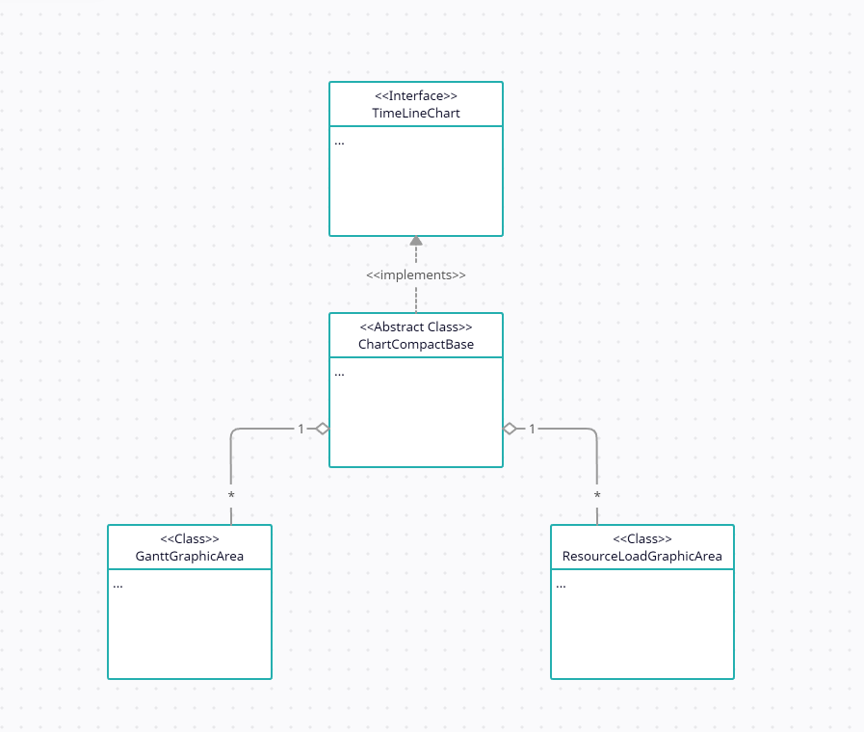

Decorator pattern allows a user to add new functionality to an existing object without altering its structure. This type of design pattern comes under structural pattern as this pattern acts as a wrapper to existing class.

This pattern creates a decorator class which wraps the original class and provides additional functionality keeping class methods signature intact.

The ChartComponentBase class is decorated/wrapped by the GanttFraphicArea  and ResourseLoadGraphicArea classes which both expand on the decorator class (ChartComponentBase) without altering its implementation.